**DAILY ONLINE ACTIVITIES SUMMARY**

|  |  |  |  |  |  |  |  |
| --- | --- | --- | --- | --- | --- | --- | --- |
| **Date:** | **21/05/2020** | | | | **Name:** | **Churashma** | |
| **Sem & Sec** | **4th SEM 'A' Section** | | | | **USN:** | **4AL18CS019** | |
| **Online Test Summary** | | | | | | | |
| **Subject** | | **Micro controller embedded system** | | | | | |
| **Max. Marks** | | **30** | | **Score** | | **17** | |
| **Certification Course Summary** | | | | | | | |
| **Course** | **Introduction to digital marketing** | | | | | | |
| **Certificate Provider** | | | **greatlearning academy** | **Duration** | | | **1.5 hours** |
| **Coding Challenges** | | | | | | | |
| **Problem statement 1:Write a C program to implement SRTF process scheduling.**  **Problem statement 2:Write a C program to construct a singly linked list by removing duplicate elements in the sorted linked list.**  **Problem statement 3:**Write a c program to create sll with n elements and reverse the elements using c | | | | | | | |
| **Status: completed** | | | | | | | |
| **Uploaded the report in Github** | | | | **yes** | | | |
| **If yes Repository name** | | | | **https://github.com/Churashma/Lockdown-coding** | | | |
| **Uploaded the report in slack** | | | | **yes** | | | |

ONLINE TEST DETAILS: MES test was scheduled from 10:00 am t0 10:30am .The portion for the IA was 1st module there were 30 questions and the time assigned was 30 minutes the questions were mcq type.

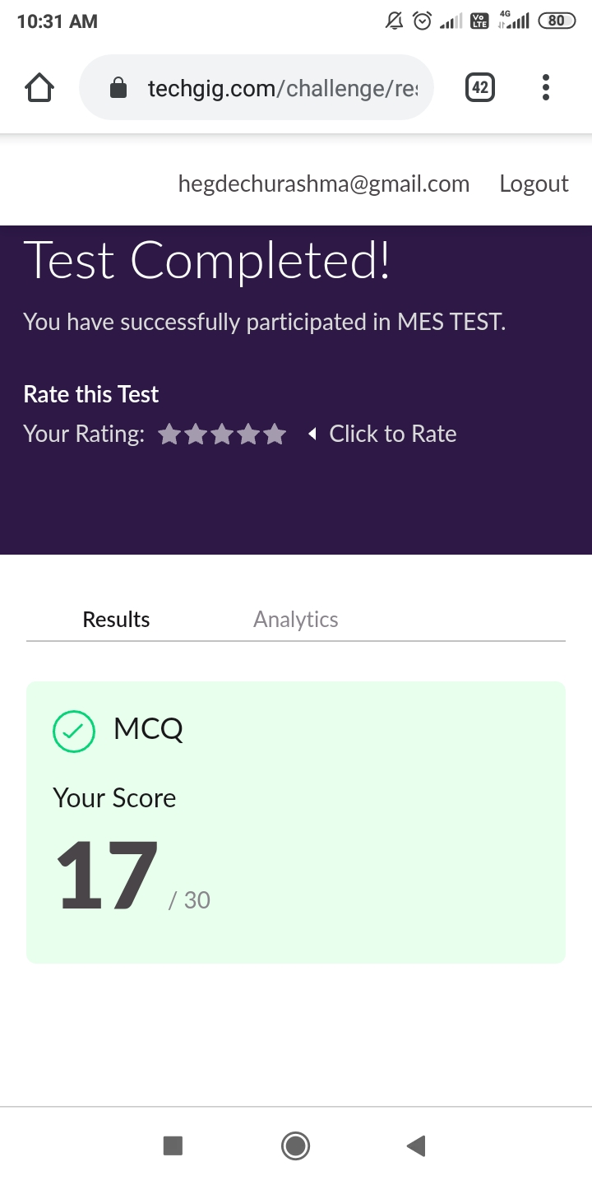

CERTIFICATION COURSE DETAILS:

This course aims to: Introduce you to the wide arena of digital marketing in the context of new media. Help understand the customer journey through the various stages from discovery to adoption of the product.Understand Facebook as an important channel to reach consumers through its advertising capabilities.Then I studied about the new media condition and understanding brand purpose.

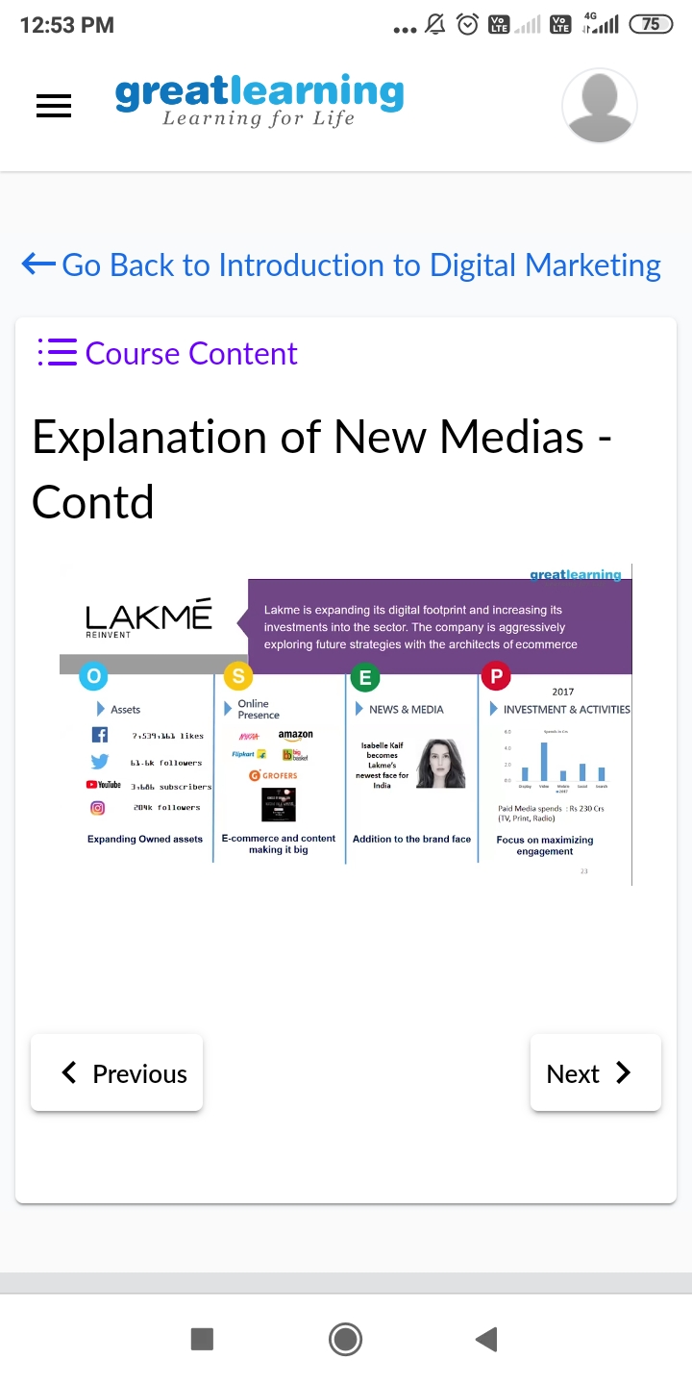

**CODING CHALLENGES DETAILS**:

**Problem statement 1: Write a C program to implement SRTF process scheduling.**

**Input: A set of processes with their burst time and arrival time**

**Output: The processes scheduled based on the arrival time and a smaller burst time.**

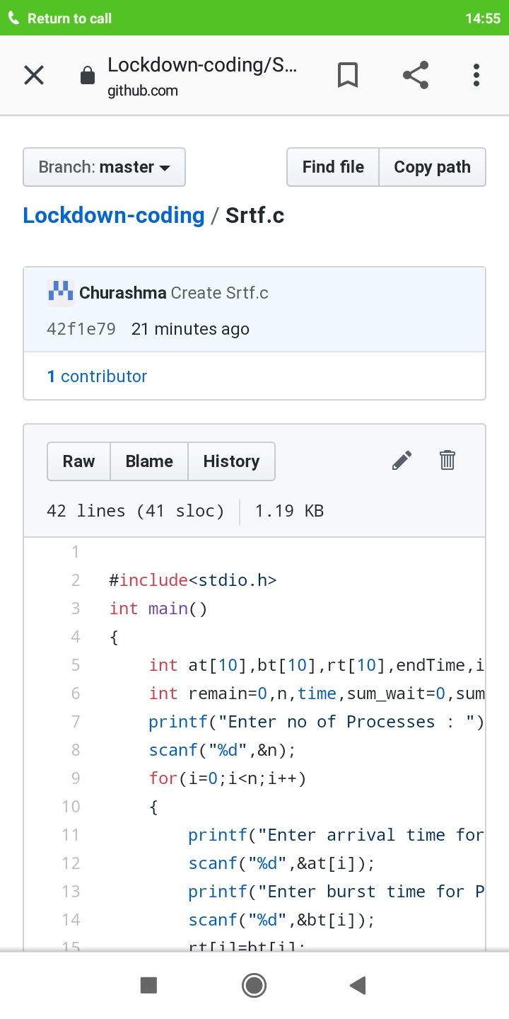

**Problem statement 2 : Write a C program to construct a singly linked list by removing duplicate elements in the sorted linked list**

**Description:**

**Take a sorted list and traverse the list. Compare the current node element with next adjacent node. If it is same then delete second element, if not retain. Finally print the resulting list.**

**Sample output:**

**Given list {1,2,2,3,3,3,4}**

**Resulting list{1,2,3,4}**

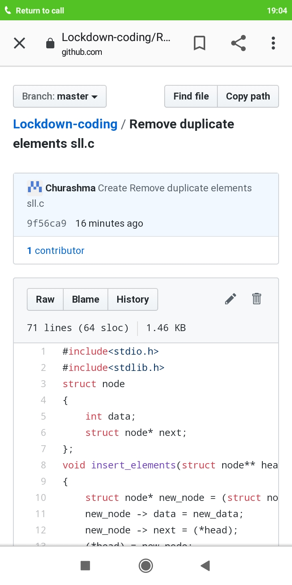

**Problem statement 3 : Write a c program to create sll with n elements and reverse the elements using c.**

